
Today's Date: 19-May-2015

PROPOSAL SPECIALLY PREPARED
FOR
INDOCHINA TRAVEL GROUP

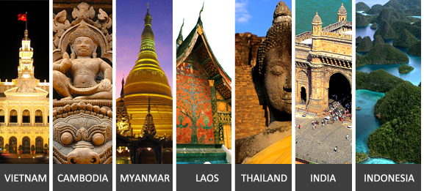

LAO Green Promo Package Asia Market
LAOS



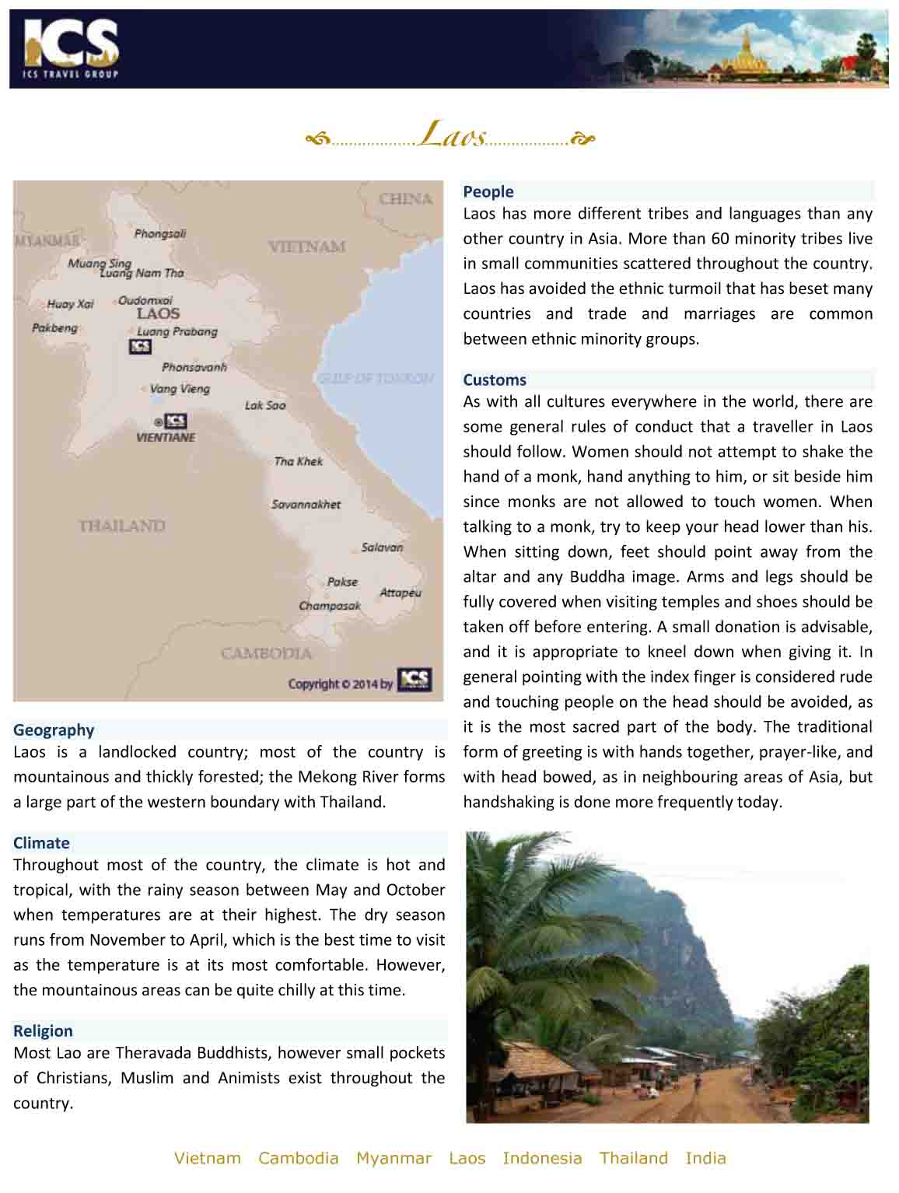

QUOTE REFERENCE # PRV1500237
LAO Green Promo Package Asia Market, 5 days

Day 1 | Vientiane
Arrival in Vientiane
Transfer
Sightseeing in Vientiane by Tuk Tuk (Half Day, Private)
Overnight in Vientiane

Day 2 | Vientiane -Vang Vieng (Breakfast)
By vehicle from Vientiane to Vang Vieng (157 kms)
Visit Vang Xang
Visit Vang Xang, an 11th century Buddhist archaeological site, where primitive Buddha images have been carved into the cliff.
Overnight in Vang Vieng

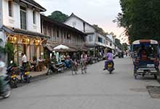 | 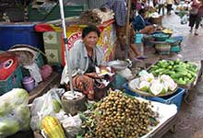 | 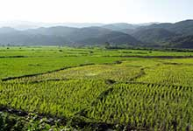

Day 3 | Vang Vieng (Breakfast)
Sightseeing around Vang Vieng with short trek (including Not)
This small town north of Vientiane is nestled in a scenic bend in the Nam Song River. The west bank of the river is lined with tunnels and caverns and the limestone cliffs are one of a kind. Stop at a Hmong village in Ban Pha Thao and then continue walking (3 km. 1 - 2 hours) to Tham Pha Thao Cave and Tham Xang Cave, or Elephant Cave, which contains a few Buddha images and a Buddha footprint along with the elephant shaped stalactites which give the cave its name. Continue to a famous cave, Tham Chang Cave, which was used as a refuge against marauding Chinese in the early 19th century. Then enjoy a short trek through rice paddies (2-3 hours).

Note: Tham Xang Cave and Tham Pha Thao are Not recommended from May to September due to the high water current in the caves and bad road conditions.
Overnight in Vang Vieng

Day 4 | Vang Vieng (Breakfast / Lunch: Meals incl. in itinerary (Laos) )
Kayaking and caving adventure on the Nam Song River (SIC) (6.15 Hours)
We will be transferred from Vang Vieng to the Khmu village of Vieng Samay, about 10 km north of Vang Vieng. After an introduction to the basics of kayaking, the Nam Song offers various small but fun rapids on the way to the first stop at the cave of Tham Nam Thaem. This cave cuts straight through the mountain, so one emerges on the other side of the range for some panoramic views of the Nam Kouang Valley.

A trek back over a small pass leads up to a Lao style picnic lunch on the riverside. The next paddle stop is at the Organic Farm, where mulberry tea and a variety of fruit wines are produced.

The Tham Non Cave lies further downstream. As one of the biggest caves in Vang Vieng, it served as a rescue shelter for the villagers during the Second Indochina War. Today it is home to a bat colony and "The Magic Stone of Vang Vieng".

The final leg is a gentle paddle - before returning to Vang Vieng in time to catch the sunset from the terrace of the Ban Sabai Riverside Bungalows.

Approximately: 15 minutes transfer / 4 hours kayaking / 1 hour caving / 1 hour hiking
Overnight in Vang Vieng

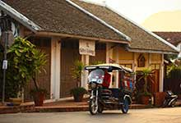 | 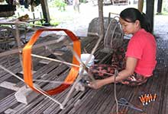 | 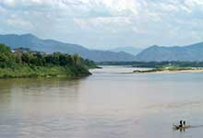

Day 5 | Vang Vieng (Breakfast)
By vehicle from Vang Vieng to Vientiane with a boat trip on Nam Ngum Lake
Start with a visit to Talat Fish Market in Huay Mor. Continue with a boat ride on Nam Ngum Lake, a serene, man-made reservoir which also generates most of the electricity sold to Thailand. Stop at a salt field in Ban Keun. Drive to the south through the scenic province of Vientiane. The climate is pleasant and the views are nice, with mountains and cliffs along the first part of the journey.

End of Services provided by ICS
**Note: Itinerary subject to change due to availability and schedules

Package price quoted NETT PER PERSON in US Dollar based on twin share
in US$ p.p | 2+ Pax | Sgl Suppl.
Var A. | 409 PER PERSON | 77 PER PERSON
Var B. | 451 PER PERSON | 124 PER PERSON
Var C. | 565 PER PERSON | 227 PER PERSON

**Note: Prices are current as of today but will be subject to any additional airfare, airport taxes and fuel increases that occur without our prior notice, and we reserve the right to adjust our quotes accordingly.
- Above rates are valid for 30 days from the date of quotation for travel between 01-Nov-14 to 31-Oct-15
- Surcharge for triple room (rate per room where extra bed is available): US$2 for Var. A. Single supplement will be charged where extra bed option is not available.
- Reduction for triple room (rate per room where extra bed is available): US$15 for Var. B; US$48 for Var. C. Single supplement will be charged where extra bed option is not available.
- Child reduction (sharing bed of parents): under 2 years FOC.
- Children under 12 years receive a 30% discount on adult rate (sharing bed of parents).
- Children requesting extra bed will receive the standard triple reduction as mentioned in our proposals.
- An additional surcharge may be applicable for bookings that fall within the Peak Season dates. In these cases, ICS will automatically apply the additional charge and advise you

HOTELS
Location | Var. A | Var. B | Var. C
Vientiane | Mandala Boutique Hotel (F.Le Leela Hotel)3*  Superior  http://www.mandalahotel.asia | Ibis Vientiane Nam Phu Hotel3*  Standard room (no extra bed for TPL available)  http://www.accorhotels.com | Salana Boutique Hotel4* (+)  Superior (no extra bed for TPL available)  http://www.salanaboutique.com
Vang Vieng | The Elephant Crossing Hotel3*  Standard Twin-Share  http://www.theelephantcrossinghotel.com | Silver Naga Hotel4*  Deluxe Twin-Share  http://www.silvernaga.com | Riverside Boutique Resort5*  Deluxe  http://www.riversidevangvieng.com

Accommodation in hotels is subject to availability. If the listed hotel is fully booked, alternate accommodation will be offered. All hotels are rated by ICS at its discretion.
Note: There is no standard method of rating hotels, transport services, guides etc across the world. Many countries have difering official and unofficial ways of assessing these services and some do not rate services at all. ICS uses its discretion to rate services. Agents should check with ICS at time of booking to clarify which level of service is being booked and notify this to clients.

INCLUDED SERVICES:
- English-speaking guide.
- Accommodation in hotels as mentioned above or equivalent.
- Meals according to itinerary / Breakfast box in lieu of ABF when early morning flight
- Boat ticket(s) according to the itinerary.
- Ground transportation in private A/C vehicle
- 1 complimentary bottle of drinking water and 1 cold towel per person per half day tour/ 2 bottles of water and 2 cold towels per person per full day tour.
- Sightseeing incl. admission fees according to itinerary.

EXCLUDED SERVICES:
- Visa fees, drinks, personal expenses | Laos

Please note that general terms and conditions apply as stated in our Terms and Conditions; unless indicated otherwise. | Terms and Conditions; | unless indicated otherwise.

To guarantee the quote a written booking request, or purchase order must be received by ICS within the validity period. Series contracts and catalogue contracts are exempt.
ICS reserves the right to re-price, alter or revise this quotation if:
- Your booking request is received after the 30-day validity period
- There is an increase of airport tax, fuel surcharge or ticket fare.

Indochina Services (S) Pte. Ltd.
RS Tower, 35th Floor
121/096-097 Rachadapisek Road,
Dindaeng, Bangkok 10400
Telephone : (+66) 2 2487485 Fax : (+66) 2 2488509 - 10
ICS Travel Group 2015

