
Today's Date: 19-May-2015

PROPOSAL SPECIALLY PREPARED
FOR
INDOCHINA TRAVEL GROUP

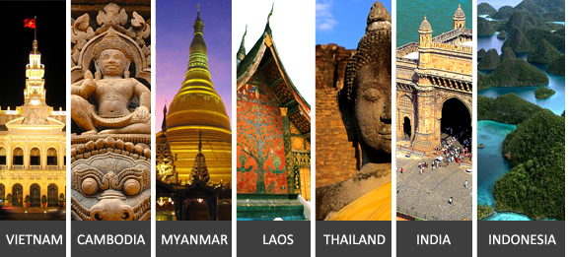

CM Green Promo Package Asia Market
CAMBODIA



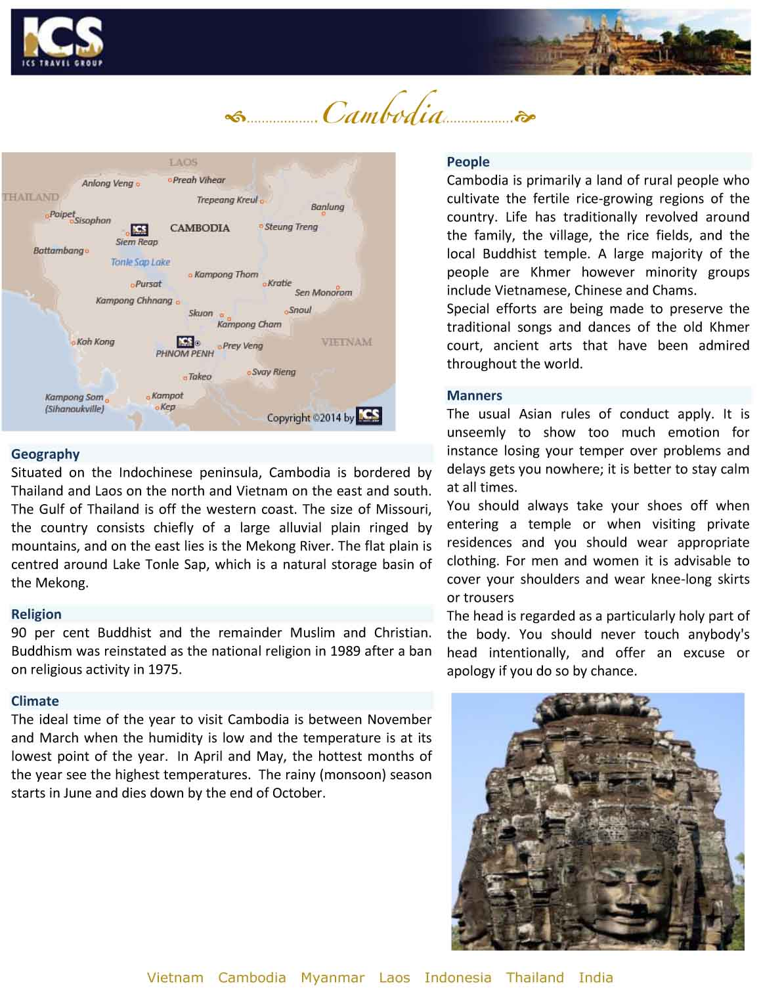

QUOTE REFERENCE # PRV1500232
CM Green Promo Package Asia Market, 5 days

01-Jun-15 (Monday) | Siem Reap
Arrival in Siem Reap
Transfer (6 kms)
Overnight in Siem Reap

02-Jun-15 (Tuesday) | Siem Reap (Breakfast)
Sightseeing in Angkor (9 Hours)
The crowning jewel of Khmer architecture, Angkor Wat is the national symbol and the highlight of any visit to Cambodia. The largest, best preserved, and most religiously significant of the Angkor temples, Angkor impresses visitors both by its sheer scale and beautifully proportioned layout, as well as the delicate artistry of its carvings. To approach the temple, first cross the vast moat, continuing along a broad causeway lined with naga balustrades. After entering the main building, ascend through a series of galleries and courtyards before reaching the central sanctuary, which offers beautiful views back over the causeway and across the surrounding countryside. On the way, stop to enjoy the intricate stone carvings that adorn nearly every surface, with some 1,700 Apsaras, or celestial dancers, sculpted into the walls. Along the outer gallery walls run the longest continuous bas-relief in the world, which narrates stories from Hindu mythology, including the famous Churning of the Ocean of Milk. Angkor Wat is stunning at any time of the day, but sunrise and sunset are especially beautiful times to watch the play of light on the stones.

The fortified city of Angkor Thom covers an area of 10 square km. Enclosed by a wall and wide moats, the city includes many of Angkor's most popular sights. Enter by the monumental South Gate over a causeway lined on either side by statues of demons and gods, each carrying a giant naga. Continue to the Terrace of the Elephants and the Terrace of the Leper Kings, former spaces for public cermonies, both adorned with dramatic bas reliefs. Visit the ruined Baphuon, Royal Enclosure and Phimeanakas before continuing to the mysterious Bayon Temple. In this temple, one of the most popular and compelling in Angkor, explore the galleries of beautifully preserved bas reliefs and ascend narrow stairs to reach the central sanctuary, where you will find giant stone faces smiling enigmatically down at you from every angle.

Visit Ta Prohm, one of the most popular attractions of Angkor as much of the jungle has not been cleared and it looks very much as most of the Angkor monuments would have appeared when European explorers first stumbled across them.

Watch the sunset over the Cambodian countryside from the upper terraces of an ancient Angkorian temple.
Overnight in Siem Reap
TIP OF THE DAY: Chill out at the famous Pub Street where there are restaurants, bars, street food, and souvenir shops or simply just sit and chill with a relaxing street foot massage and watch the world go by.

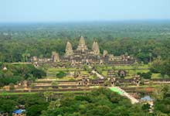 | 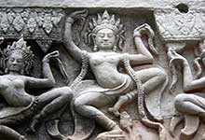 | 

03-Jun-15 (Wednesday) | Siem Reap -Local Village (Cambodia) (Breakfast / Lunch: Meals incl. in itinerary (Cambodia) / Dinner: Meals incl. in itinerary (Cambodia) )
Homestay Experience at Bong Thom Homestay in Siem Reap, Day 1 of 2 (8 Hours)
Today head from the hotel to Kbal Spien, also known as the river of 1,000 lingas which hosts carvings on the riverbed (in a similar manner as Kulen). It should be more spectacular but many of the carvings have been looted. Near Kbal Spien is a waterfall that can be reached by hiking 2km uphill. After Lunch visit Banteay Srei temple, visit the wildlife conservation centre, and drive to the home stay where guests will enjoy cooking class and dinner. Spend the night at the homestay.
Excursion by Ox cart/cycling at the local villages (8 Hours)
Enjoy lunch at the local village terrace.
After lunch guests can participate in an ox cart ride or go on a cycling tour to visit villages, a butterfly garden, sugar palm makers and handicraft production.
(The availability of sugar palm makers and the handicraft program depends on the season(normally around May- Oct). If the program is not available, an alternative program e.g. palm leave basket makers, farm visit, etc. will be offered)
Overnight in Local Village (Cambodia)

04-Jun-15 (Thursday) | Siem Reap (Breakfast / Lunch: Meals incl. in itinerary (Cambodia) )
Homestay Experience at Bong Thom Homestay in Siem Reap, Day 2 of 2 (8 Hours)
Enjoy the breakfast and the sunrise at the homestay. Take an 8km Ox cart ride from the homestay to visit Phnom Bok temple and the surrounding villages, after that go by vehicle from Phnom Bok to visit Bantey Samrer temple. After, drive back to the homestay and enjoy lunch with fresh fruit at the nature farm. Return to hotel.
Overnight in Siem Reap

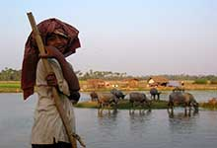 | 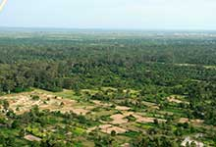 | 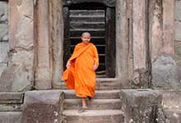

05-Jun-15 (Friday) | Siem Reap (Breakfast)
Excursion by boat to Chong Kneas floating village and visit Phsar Chah (Old Market) (4 Hours)
Take a boat ride to Chong Kneas Village to view the scenery and day to day life of the communities living around the lake. Visit Psah Chah Market, originally destroyed by the Khmer Rouge in 1975 and reopened in 1996. It has many interesting food stalls and souvenir shops.
Transfer (6 kms)

End of Services provided by ICS
**Note: Itinerary subject to change due to availability and schedules

Package price quoted NETT PER PERSON in US Dollar based on twin share
in US$ p.p | 2+ Pax | Sgl Suppl.
Var A. | 366 PER PERSON | 53 PER PERSON
Var B. | 379 PER PERSON | 66 PER PERSON
Var C. | 457 PER PERSON | 145 PER PERSON

**Note: Prices are current as of today but will be subject to any additional airfare, airport taxes and fuel increases that occur without our prior notice, and we reserve the right to adjust our quotes accordingly.
- Above rates are valid for 30 days from the date of quotation for travel between 01-Nov-14 to 31-Oct-15
- Surcharge for triple room (rate per room where extra bed is available): US$8 for Var. B. Single supplement will be charged where extra bed option is not available.
- Reduction for triple room (rate per room where extra bed is available): US$4 for Var. A; US$33 for Var. C. Single supplement will be charged where extra bed option is not available.
- Child reduction (sharing bed of parents): under 2 years FOC.
- Children under 12 years receive a 30% discount on adult rate (sharing bed of parents).
- Children requesting extra bed will receive the standard triple reduction as mentioned in our proposals.

HOTELS
Location | Var. A | Var. B | Var. C
Siem Reap | Casa Angkor Hotel 3*  Superior  http://www.casaangkorhotel.com  Angkor Holiday Hotel 4*  Superior  http://www.angkorholidayhotel.com  Royal Empire Hotel 4*  Superior  http://www.royalempirehotel.com | Angkor Riviera Hotel 4*  Superior (no extra bed for TPL available)  http://www.angkorriviera.com/  Khemara Angkor Hotel 4*  Deluxe  http://www.khemaraangkor.com/ | Sokha Angkor Resort (F.Sokha Angkor Hotel & Spa) 5*  Deluxe City View
Local Village (Cambodia) | Village Stay (Cambodia)  Home Stay / Tent | Village Stay (Cambodia)  Home Stay / Tent | Village Stay (Cambodia)  Home Stay / Tent

Accommodation in hotels is subject to availability. If the listed hotel is fully booked, alternate accommodation will be offered. All hotels are rated by ICS at its discretion.
Note: There is no standard method of rating hotels, transport services, guides etc across the world. Many countries have difering official and unofficial ways of assessing these services and some do not rate services at all. ICS uses its discretion to rate services. Agents should check with ICS at time of booking to clarify which level of service is being booked and notify this to clients.

INCLUDED SERVICES:
- English-speaking guide.
- Accommodation in hotels as mentioned above or equivalent.
- Meals according to itinerary / Breakfast box in lieu of ABF when early morning flight
- Boat ticket(s) according to the itinerary.
- Ground transportation in private A/C vehicle
- 1 complimentary bottle of drinking water and 1 cold towel per person per half day tour/ 2 bottles of water and 2 cold towels per person per full day tour.
- Sightseeing incl. admission fees according to itinerary.

EXCLUDED SERVICES:
- Visa fees, drinks, personal expenses | Cambodia

Please note that general terms and conditions apply as stated in our Terms and Conditions; unless indicated otherwise. | Terms and Conditions; | unless indicated otherwise.

To guarantee the quote a written booking request, or purchase order must be received by ICS within the validity period. Series contracts and catalogue contracts are exempt.
ICS reserves the right to re-price, alter or revise this quotation if:
- Your booking request is received after the 30-day validity period
- There is an increase of airport tax, fuel surcharge or ticket fare.

Indochina Services (S) Pte. Ltd.
RS Tower, 35th Floor
121/096-097 Rachadapisek Road,
Dindaeng, Bangkok 10400
Telephone : (+66) 2 2487485 Fax : (+66) 2 2488509 - 10
ICS Travel Group 2015

