
Today's Date: 19-May-2015

PROPOSAL SPECIALLY PREPARED
FOR
INDOCHINA TRAVEL GROUP

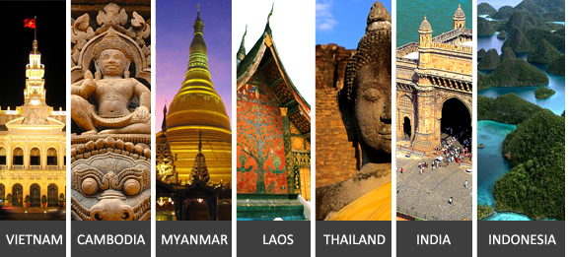

VN Green Promo Package Asia Market
VIETNAM



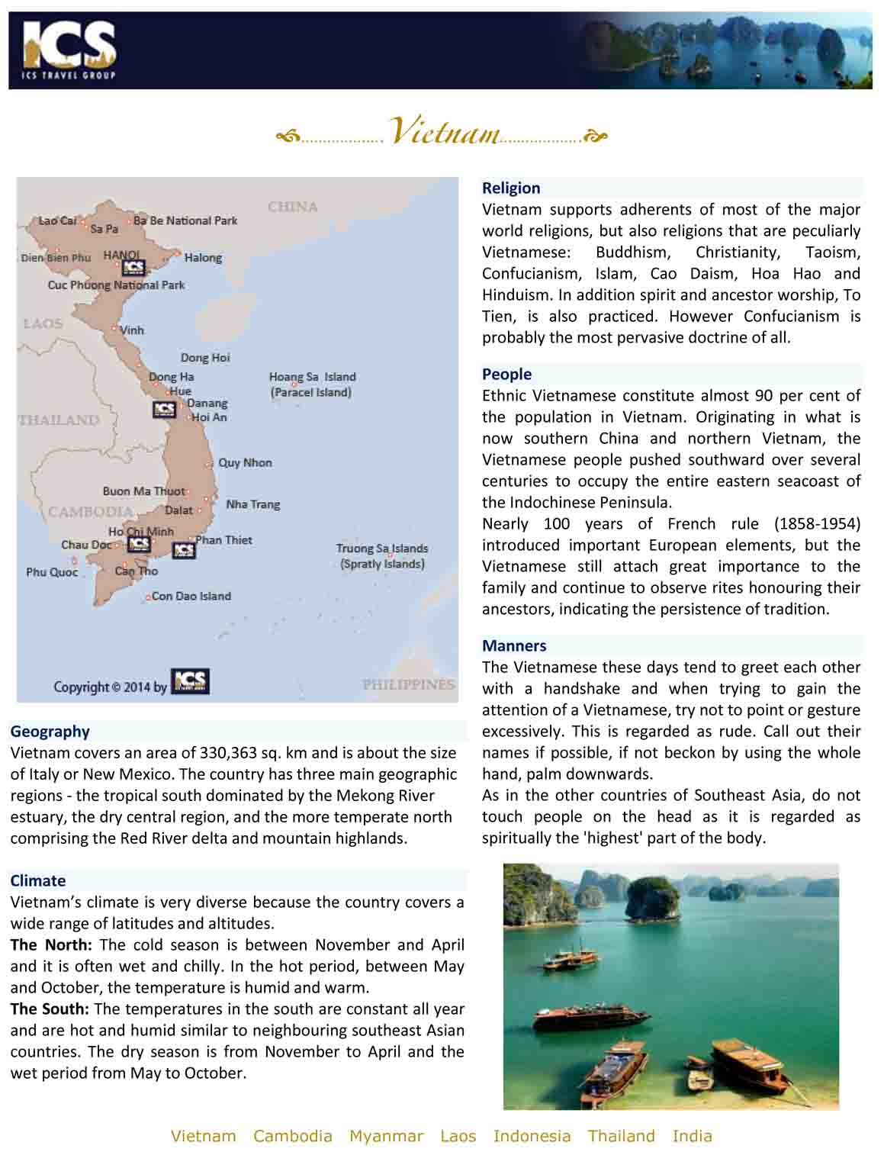

QUOTE REFERENCE # PRV1500230
VN Green Promo Package Asia Market, 5 days

Day 1 | Hanoi -Train
Arrival in Hanoi
Transfer (35 kms)
Transfer to/from train station (5 kms)
By train from Hanoi to Lao Cai
Overnight in Train

Day 2 | Lao Cai -Sa Pa (Breakfast)
Arrival in Lao Cai (Vietnamese/Chinese border)
Transfer from Lao Cai to Sa Pa (38 kms)
Breakfast at local restaurant
Visit Ham Rong Mountain and San May (Cloud Yard)
Overnight in Sa Pa

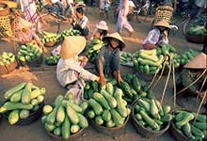 | 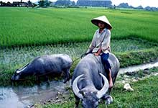 | 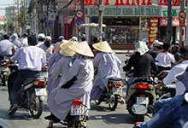

Day 3 | Sa Pa (Breakfast)
Excursion to remote tribal villages (Thanh Phu - My Son - Nam Sai - Nam Cang)
Leaving Sapa at about 08.30am by vehicle and travel southwards to Sapa. The first 16km portion of the road offers spectacular landscapes of Hoang Lien mountain range, Fansipan peak as well as marvellous terraced rice fields of the Muong Hoa valley. Enjoy several photo stops before arriving to Su Pan commune where customers will pay a visit to Hoa Su Pan, a small hamlet of the Black Hmong for half an hour.

Continue the trip along the road further south to Muong Bo valley of Thanh Phu commune. Walking along the large village path for nearly an hour, paying visiting to several homes of the Tai people who live in spacious houses built on stilts, witnessing their daily life and experiencing their hospitality. Lunch break in a local home.

Continue the trip in the afternoon with a short drive along the rocky road to My Son and spend a half an hour to walk around this charming village of the Xa Pho ethnicity (whose population is only more than 6 thousand people) for a brief understanding of their very unique culture and custom. Then travel further to Nam Cang commune for visiting a beautiful and prosperous village of the Red Dao people in Nam Than village. This portion of the road ride offers beautiful scenery of the Nam Sai Valley. Leave Nam Cang in mid-afternoon and drive back along the same way to Sapa.
Overnight in Sa Pa

Day 4 | Sa Pa -Lao Cai -Train (Breakfast / Lunch: Meals incl. in itinerary (Vietnam) )
Trekking excursion to Mong Sen and Ta Phin
Travel by road from Sapa to Mong Sen Bridge with several stops along the way to view the spectacular landscape.

Start with a three-hour walk on trails that wind their way along steep hillsides by the eastern bank of the Mong Sen Stream to Mong Sen 2 Village. Spend some time to explore these three isolated hamlets, home to the Black Hmong and Red Zao people.

After lunch continue hiking for about an hour up and down hills towards the Ta Phin Valley to arrive at Ta Phin commune in the mid afternoon. Take a walk around this stunning valley and visit some of the Red Zao families. The Red Zao women are famous for their handicraft skills, and wear traditional clothes covered with beautifully embroidered motifs that depict their religion, beliefs and the surrounding nature. Transfer by road back to Sapa.
Transfer to Lao Cai train station (38 kms)
By train from Lao Cai to Hanoi
Overnight in Train

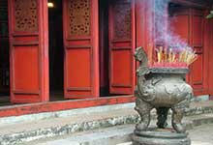 | 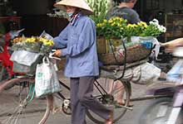 | 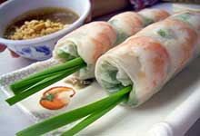

Day 5 | Hanoi
Transfer to/from train station (5 kms)
Transfer (35 kms)
Special Note: breakfast is not included on this day

End of Services provided by ICS
**Note: Itinerary subject to change due to availability and schedules

Package price quoted NETT PER PERSON in US Dollar based on twin share
in US$ p.p | 2+ Pax | Sgl Suppl.
Var A. | 435 PER PERSON | 47 PER PERSON
Var B. | 520 PER PERSON | 204 PER PERSON

**Note: Prices are current as of today but will be subject to any additional airfare, airport taxes and fuel increases that occur without our prior notice, and we reserve the right to adjust our quotes accordingly.
- Above rates are valid for 30 days from the date of quotation for travel between 01-Nov-14 to 31-Oct-15
- Reduction for triple room (rate per room where extra bed is available): US$19 for Var. A; US$4 for Var. B. Single supplement will be charged where extra bed option is not available.
- Child reduction (sharing bed of parents): under 2 years FOC.
- Children under 12 years receive a 30% discount on adult rate (sharing bed of parents).
- Children requesting extra bed will receive the standard triple reduction as mentioned in our proposals.
- An additional surcharge may be applicable for bookings that fall within the Peak Season dates; Christmas, New Year and Lunar New Year (TET Festival). In these cases, ICS will automatically apply the additional charge and advise you immediately.

HOTELS
Location | Var. A | Var. B
Train | King Express  Deluxe Cabin with 4 beds/Hanoi-Lao Cai (no extra bed for TPL available)  http://www.sapadaily.com | King Express  Private Deluxe Cabin with 2 beds/Hanoi-Lao Cai (no extra bed for TPL available)  http://www.sapadaily.com
Sa Pa | Bamboo Sapa Hotel3*  Superior  http://www.bamboosapahotel.com.vn | U Sapa Hotel4* (+)  Superior  http://| www. usapavietnam.com

Accommodation in hotels is subject to availability. If the listed hotel is fully booked, alternate accommodation will be offered. All hotels are rated by ICS at its discretion.
Note: There is no standard method of rating hotels, transport services, guides etc across the world. Many countries have difering official and unofficial ways of assessing these services and some do not rate services at all. ICS uses its discretion to rate services. Agents should check with ICS at time of booking to clarify which level of service is being booked and notify this to clients.

INCLUDED SERVICES:
- English-speaking guide.
- Accommodation in hotels as mentioned above or equivalent.
- Meals according to itinerary / Breakfast box in lieu of ABF when early morning flight
- Train ticket(s) according to the itinerary.
- Ground transportation in private A/C vehicle
- 1 complimentary bottle of drinking water and 1 cold towel per person per half day tour/ 2 bottles of water and 2 cold towels per person per full day tour.
- Sightseeing incl. admission fees according to itinerary.

EXCLUDED SERVICES:
- Visa fees, drinks, personal expenses | Vietnam

Please note that general terms and conditions apply as stated in our Terms and Conditions; unless indicated otherwise. | Terms and Conditions; | unless indicated otherwise.

To guarantee the quote a written booking request, or purchase order must be received by ICS within the validity period. Series contracts and catalogue contracts are exempt.
ICS reserves the right to re-price, alter or revise this quotation if:
- Your booking request is received after the 30-day validity period
- There is an increase of airport tax, fuel surcharge or ticket fare.

Indochina Services (S) Pte. Ltd.
RS Tower, 35th Floor
121/096-097 Rachadapisek Road,
Dindaeng, Bangkok 10400
Telephone : (+66) 2 2487485 Fax : (+66) 2 2488509 - 10
ICS Travel Group 2015

